Theory for coupled large deformation and hydrolytic degradation in hydrogels

Abstract: Biodegradable synthetic hydrogels have emerged as promising materials for tissue engineering and drug delivery applications. However, their successful implementation requires precise control on their degradation response in terms of mechanical properties, swelling behaviour and mass loss. Physically based models that relate the (evolving) network structure to the mechanical behaviour during degradation are therefore needed. In this work, we propose a continuum theory for coupled large deformations and hydrolytic degradation, which is the primary degradation pathway in hydrogels used in biomedical applications. The theory is written in a thermodynamically consistent framework, allowing us to identify and quantify coupled chemo-mechanical effects on hydrolysis. We also propose specific constitutive models for the evolution of the elastic modulus and mass loss fraction during degradation in terms of the evolving network parameters. Two model hydrogel systems with different network architectures are considered, namely near-ideal Tetra-PEG gels and gels made from PLA-PEG-PLA block copolymer precursors. Model predictions are in very good agreement with experimental data up to final degradation. We have also implemented our model in Abaqus through user-subroutines to simulate degradation-induced heterogeneous swelling in representative case studies. Our model could be useful to guide the design of hydrogels with controlled degradation behaviour.

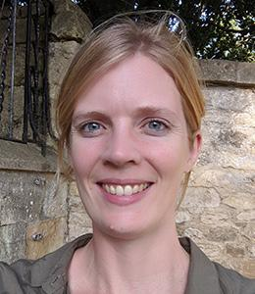

Professor Laurence Brassart is an Associate Professor in the Department of Engineering Science at the University of Oxford. She graduated from the Université Catholique de Louvain (Belgium) with a diploma in Mechanical Engineering in 2007, and with a PhD in Engineering Sciences in 2011. She then moved to the US for a postdoc at Harvard University as a Fellow of the Belgian American Educational Foundation (2011-2012), before returning to Louvain as a fellow of the National Research Fund of Belgium (“Chargé de Recherche FNRS”). From 2015 to 2019, she was a Senior Lecturer in the Department of Materials Science and Engineering at Monash University (Melbourne). She joined as an Associate Professor in August 2019 at Oxford.

Date : 25th January 2023

Time: 14:30-15:30

Room: ESRI 001, Bay Campus

