Introduction to Thermodynamics Part 2: Enthalpy and Hess’ Law

Heat energy: internal energy and work
The heat energy change in a system is symbolised by ΔQ. If a system changes at constant volume, then no mechanical work is done and so the energy change then ΔQv = ΔU.
If the system changes at constant pressure and expansion can occur, then:
ΔU = ΔQp + PΔV = ΔQp + ΔnRT

Enthalpy Change ΔH is defined as the energy absorbed or released when standard molar of materials react under standard experimental conditions under conditions of constant pressure. ΔH = ΔQp We have mentioned the enthalpy change, ΔH. This is the amount of heat energy released or absorbed when something happens at constant pressure. This can be a physical change, for example boiling or melting. A positive enthalpy change implies energy is put into the system to cause the change and a negative value implies the system has given up energy in performing the change.

Units of ΔH: Enthalpy change is measured in kJ mol⁻¹ (= 1000 J mol⁻¹).

Exothermic and Endothermic Processes
If heat is released the ΔH is negative, the energy change is said to be exothermic. This is generally favoured. If heat is absorbed the ΔH is positive, the energy change is said to be endothermic
Examples of exothermic and endothermic reactions:
Burning hydrogen: H₂ (g) + O₂ (g) = H₂O (l) ΔH = -285.3 kJmol-1 (Exothermic)
Carbon monoxide formation: CO₂ (g) + C (s) = 2CO (g) ΔH = +174.45 kJmol-1 (Endothermic)

The values of ΔH for chemical changes tell you whether energy will be released or absorbed by your system in doing its reaction. Generally exothermic reactions are considered more favourable since the system is losing energy (but this is not always the case as we shall see). There are some special cases of ΔH such as heats of combustion and formation, but all are similar.
Definitions:
The standard heat (or enthalpy) of formation (ΔHº_{f}): The enthalpy change that occurs when 1 mole of a substance is made from its elements in their standard state under standard conditions.
The standard heat (enthalpy) of combustion (ΔHº_{comb}): The enthalpy change that occurs when 1 mole of a substance is burned completely under standard conditions.
The standard heat (enthalpy) of atomisation (ΔHº_{at}) of an element refers to the heat required to form 1 mole of gaseous atoms from the element in its standards state under standard conditions. For example, in the reaction H2 (g) 2H (g), (ΔHº_{at} = +436 kJ mol⁻¹) we are splitting molecules into atoms and the process is called atomisation.

Working out ΔHs
Obviously, we could for every system we are interested in measure under controlled conditions the heat release (i.e. ΔH) for a certain reaction.

Hess’ law; the principle of constant heat summation.
Definition: The total energy change accompanying a chemical change is independent of the route by which that chemical change takes place. i.e the overall energy change in going from one set of reactants to a set of products is the same regardless of the route taken. This is an expression of the first law of thermodynamics since overall the energy in your system cannot increase or decrease and so if you have the same starting materials and products then the overall energy changes must be the same whether they have come via a simple or complicated route.
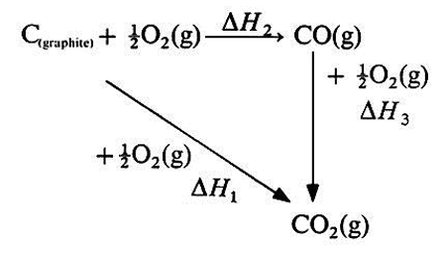
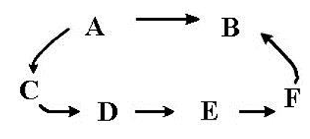
For example, AB can go via a short direct route or a longer, more indirect route. To give a specific example, the oxidation of graphite to CO₂ can go via a direct route or an indirect by forming a CO intermediary.

Standard Heats of Formation
The standard enthalpy of formation of a compound, ΔH_{f}, is the enthalpy change involved in the formation of one mole of substance from its elements each element being in its usual form at one atmosphere pressure and at the specified temperature (often 298K). The heat of formation of an element in its standard state will thus be zero. These data have been measured for many systems and we can use them in a cunning way to work out heats of reaction.
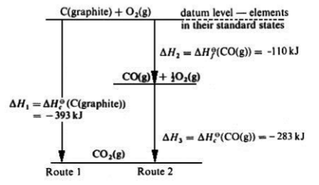
Combining Hess’ Law and Standard Heats of reaction
These are available in tables and by invoking Hess’ law we can readily calculate ΔH for reactions from the heats of formation
E.g. For a typical general reaction
aA + bD = cC + dD: ΔH = [c(ΔH_{C}) + d(ΔH_{D})] - [a(ΔH_{A}) + b(ΔH_{B})]

Heats of formation at different temperatures have been measured and are tabulated so this type of calculation is really very easy. Worked example: What is the heat of formation of methane, given ΔH_{f} (C) = 0 kJ Mol-1, ΔH_{f} (O₂) = 0 kJ Mol⁻¹ ΔH_{f} (CO₂) = 393.5 kJ Mol-1 ΔH_{f} (H2O)= -241.8 kJ Mol⁻¹⁻ , Hcomb (CH₄) = -802.1 kJ Mol⁻¹
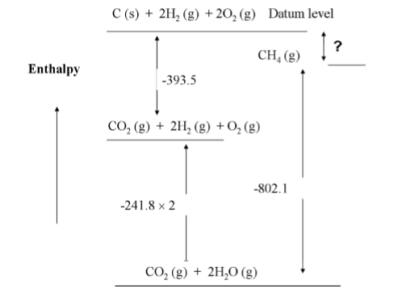
From Hess’ law then ΔHf (CH₄)= -393.5 + (2 x -241.8) - (-802.1) = -75 kJ mol⁻¹, i.e. methane is formed exothermically since 75 kJ of heat is given out when 1 mole is formed.

Energy in Fuels; Bond Energies and Enthalpies

The term Bond Dissociation Energy is used when considering the energy required to break a specific bond in singly bonded diatomic molecules. Such values are frequently measured by means of spectroscopic techniques, for example the hydrogen chlorine bond strength is found by examining the UV absorption spectrum of HCl gas: HCl (g) H (g) + Cl (g) ΔH = +431 kJ mol-1, i.e. E(H-Cl) – the bond dissociation energy of the hydrogen – chlorine bond is +431kJ mol-1. For molecules containing many atoms (polyatomic), it is not always possible to measure bond energies directly, but these can be estimated using Hess’ Law. For example – what is the C-H bond energy in a methane molecule? We will assume that the sum of the bond energies for a compound is equal to the enthalpy change involved in the atomisation of that compound from the gaseous state.
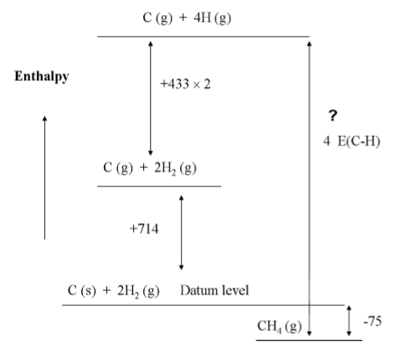
ΔH_{f} (CH₄) = +75 kJ mol-1, ΔH_{at}(C) = +716 kJ mol-1, ΔH_{at}(H₂) = +433 kJ mol⁻¹.
From the diagram: 4E (C-H) = +714 + 2 x (433) - (-75) = 1655 KJ mol⁻¹, therefore the bond dissociation energy for C-H is +414 kJ mol⁻¹.
By means of a similar calculation it can be shown that the total bond energy for ethane (C₂H₆) is 2826 kJ mol⁻¹. Ethane contains 6 C-H bonds and one C-C bond. If we assume that the C-H bond energy in ethane is the same as methane i.e. 414 kJ mol-1, then the difference in the total bond energy and the sum of the energy of the 6 C-H bonds will give us the C-C bond energy. i.e. E (C-C) = total bond energy - 6 x E(C-H) = 2826 - (6 x 414) = +342 kJ mol⁻¹.

We can also use tabulated bond energies to calculate the heats of reaction, using the expression below:

ΔH = (Total bond energy of reactants) - (Total bond energy of products).

Heat capacities
In a system in which large amounts of heat are being absorbed or given out the temperature is likely to change. Most systems therefore will have a certain heat capacity. As you heat water the temperature will rise to a different level than heating for example iron due to differences in the amount of energy that can be absorbed for a given unit of temperature increase. In the same way changing the temperature is likely to affect the heat given out or absorbed by the system. Temperature changes thus also cause changes in the enthalpies of reaction, ΔH.

The specific heat capacity, C, is defined as the heat required to raise the temperature of one gram of stuff by one degree Kelvin.
Heat change per gram = CΔT
Total heat change = mCΔT m is the mass of material
Units of CJK-¹g⁻¹.

The molar heat capacity Cp is defined as the heat require to raise the temperature of one mole of stuff by one degree Kelvin.
Heat Change = CpT per mole
Total heat change = nCpΔT

Questions
- The standard enthalpy change of vaporisation of ethanol is +43.5 KJmol⁻¹. Calculate the enthalpy change when 0.5g of ethanol vaporises at its boiling point at 1 bar (M_{r} ethanol = 46.07).

- Calculate the total enthalpy change when 1 mol of ice at 0 °C is turned into steam at 100 °C. (Take the average molar capacity of liquid to be 75.1 JK⁻¹mol⁻¹. Use the equations: ΔH_{sub} = ΔH_{fus} + ΔH_{vap} & ΔH_{total} = ΔH₁ + ΔH₂ + ΔH₃ (for the 3 stages in this reaction).

- The gaseous hydrocarbons ethene (C₂H₄) and ethane (C₂H₆) are products from the cracking of oil. The standard enthalpy changes at 298K for the reactions of graphite and hydrogen gas to form 1 mol of each of these compounds are +52.5 KJmol⁻¹ and -83.8 KJmol⁻¹ respectively.
Calculate the standard enthalpy change for the hydrogenation of ethene to ethane, at 298K.

- Calculate the standard enthalpy change of the reaction at 298K for the reaction:
3Fe₂O₃ (s) + 2NH₃ (g) 6FeO (s) + 3H₂O (l) + N₂ (g)
ΔH_{f} (Fe₂O₃) = -824.2 KJmol⁻¹; ΔH_{f} (NH₃) = -46.1 KJmol⁻¹; ΔH_{f} (FeO) = -266.3 KJmol⁻¹; ΔH_{f} (H₂O) = -285.8 KJmol⁻¹; ΔH_{f} (N₂) = 0 KJmol⁻¹.

- The main form of sugar in your diet is likely sucrose (C₁₂H₂₂O₁₁). Its combustion at 1 bar and 298K releases 5647 KJmol⁻¹ of heat. Calculate the standard enthalpy change of formation of sucrose.
(ΔH_{f298K} (CO₂ (g)) = -393.5 KJmol⁻¹ and ΔH_{f298K} (H₂O (l)) = -285.8 KJmol⁻¹

- Using values of bond enthalpies to estimate the standard enthalpy change for the gas phase isomerisation of methoxymethane to form ethanol: CH₃-O-CH₃ (g) CH₃-CH₂-OH (g).
ΔH_{bond}(C-H) = +412 KJmol⁻¹; ΔH_{bond} (C-O) = +358 KJmol⁻¹; ΔH_{bond} (C-C) = +347 KJmol⁻¹; ΔH_{bond} (O-H) = +464 KJmol⁻¹

