Complex instability phenomena in soft matter

Abstract: The loss of stability or buckling is a classical problem in elasticity. In the case of an Euler strut or buckling of a flat plate, buckling is well understood and relatively simple. However, in slender shells or growing materials, the observed instability phenomena are often complex with a high degree of multistability and featuring interesting dynamics such as pattern formation. Untangling the governing mechanics underpinning complex instability phenomena requires more sophisticated computational machinery than is currently available in commercial finite element codes. This seminar will outline some of the work conducted by the speaker throughout his Royal Academy of Engineering fellowship in creating computational methods for untangling post-buckling deformations in soft matter and growing materials, in particular the role of broken and restored symmetry in buckling-driven pattern formation.

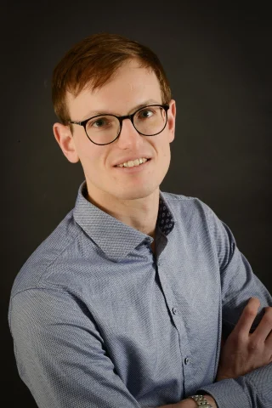

About the presenter: Dr Rainer Groh is a lecturer in Digital Engineering of Structures the University of Bristol and is currently finishing his five-year research fellowship awarded by the Royal Academy of Engineering. In 2019, he was awarded the Philip Leverhulme Prize in Engineering in recognition of his achievements as an early-career researcher. His research focuses on understanding complex instability phenomena in materials and structures using both simulations and experiments. The application of this research is in areas where instabilities are detrimental and therefore avoided (e.g., buckling collapse) and where instabilities can be embraced for functionality (e.g., shape morphing). His research is multidisciplinary spanning aerospace, mechanical, and civil engineering but has also focused on problems in biology and biomechanics. As a Chartered Engineer of the Royal Aeronautical Society, he also collaborates closely with industrial partners and has led projects with Airbus, Embraer, ESA, and NASA.

Date & Time: 15:00-16:30, 23rd February 2023
Room: B001, Engineering Central, Bay Campus

