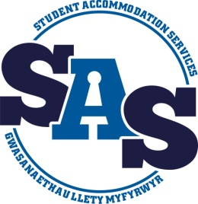
Student Accommodation Services
REPAIR REPORT FORM

You can return the form by email to: sas@swansea.ac.uk or directly to the SAS Office, Ground Floor Fulton House, Swansea University.
For any urgent repairs, such as failure of heating, water, alarms etc., please contact us as soon as possible during office hours on: Tel No. +44 (0) 1792 295101 or out of hours, Fulton House Security on Tel. +44 (0) 1792 205678
NAME: ________________________________________________ _STUDENT NO:_______________
PROPERTY:______________________________________________ROOM NO:__________________
PROPERTY TEL NO:____________________________CONTACT TEL NO:________________________
DATE FAULT / PROBLEM NOTICED:_______________________TIME:___________________
FAULT / PROBLEM: (Please provide as much information as possible)

__________________________________________________________________________________

LOCATION OF FAULT / PROBLEM:_______________________________________________________
__________________________________________________________________________________
HAS THIS PROBLEM BEEN REPORTED BEFORE: YES / NO IF YES DATE:____________________

SIGNED: ____________________________________________ DATE: ________________________

FOR OFFICE USE ONLY:
ACTION REQUIRED: CP SD W/O L/L
ATTENDED: AM PM
CATEGORY: COMPLETED FURTHER ACTION REQUIRED
NOTES:
PROBLEM RESOLVED: YES / NO DATE:
FURTHER ACTION REQUIRED YES / NO DATE:
WORKS COMPLETE: YES / NO DATE:

