Chief investigators are responsible for controlling the risks associated with their project by ensuring RA are undertaken before research starts and reviewed
regularly throughout the project life span (see Appendix 2 for more details).

Risk Assessment on Swansea University Sponsored studies

Please complete and return to Research Governance
Title of the study
IRAS number |  | Sponsor Study Reference
Chief Investigator |  | CI contact email
Student name (if applicable |  | Student contact email
Faculty in Swansea University |  | Assessment Date
REC/School Ethics Reference |  | Review Date (if applicable)

Part 1: Risk Assessment

Please refer to Appendix 1 Risk Matrix when completing the S and L columns

What are the hazards? | Who might be harmed? | How could they be harmed? | What are you already doing? | S | L | Risk  (SxL) | Do you need to do anything else to manage this risk? | S | L | Risk  (SxL) | Additional Action Required

Part 2: Actions arising from risk assessment

Actions | Lead | Target Date | Done Yes/No

Appendix 1. Risk Matrix

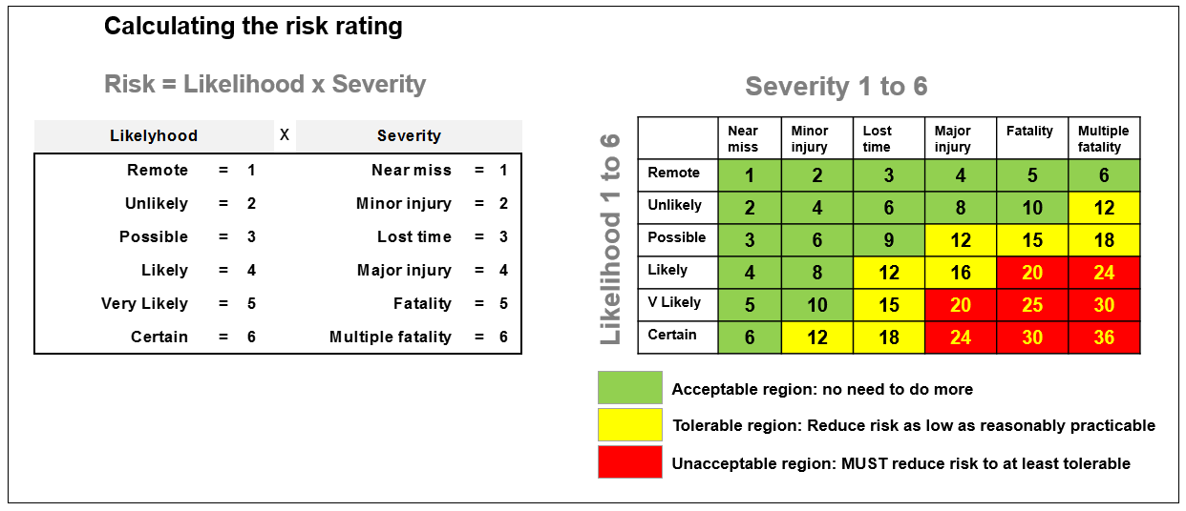

Appendix 2. Research Risk Assessment Flow Chart

