Student’s Fee Query Journey in Learner Gateway

This document will provide details of what a student will need to do to complete their Fee Status Questionnaire via Learner Gateway.

This document can be used as an aid when completing your fee query.

You will complete your application form and, if you cannot be assigned a fee status, your fee status will become a Fee Query.

Your Application Dashboard will then automatically create a task for you to complete a fee status questionnaire.

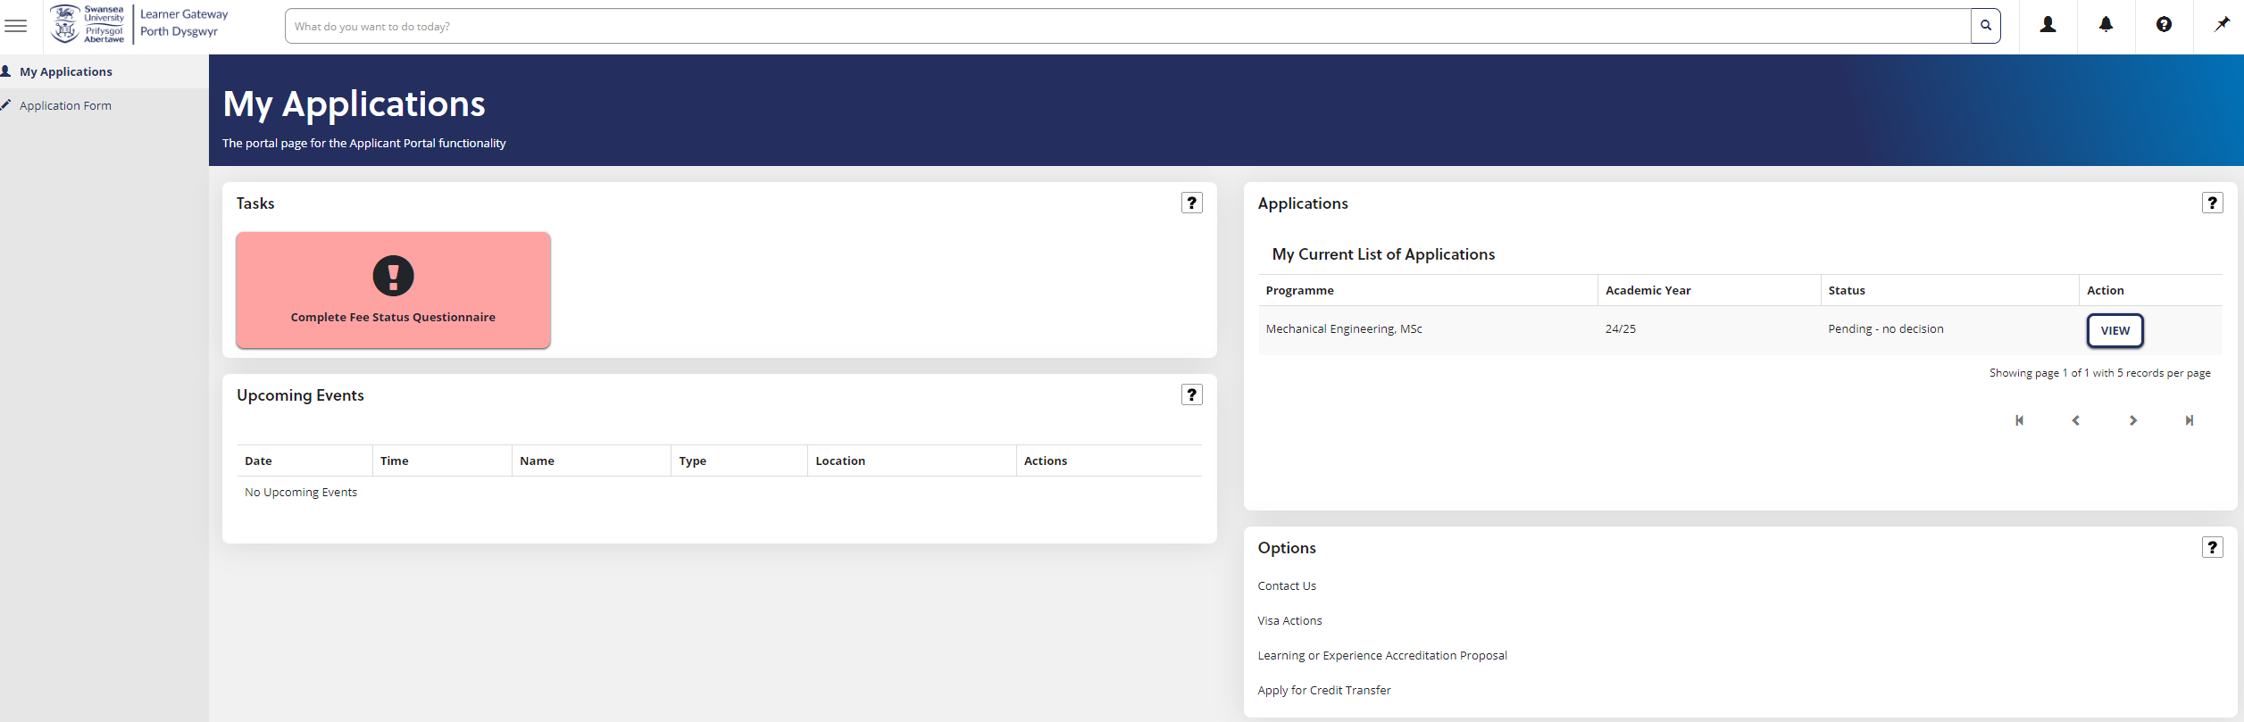

- You need to click on the “Complete Fee Status Questionnaire” task button and it will take you to this screen where you need to press Complete to take you to your questionnaire

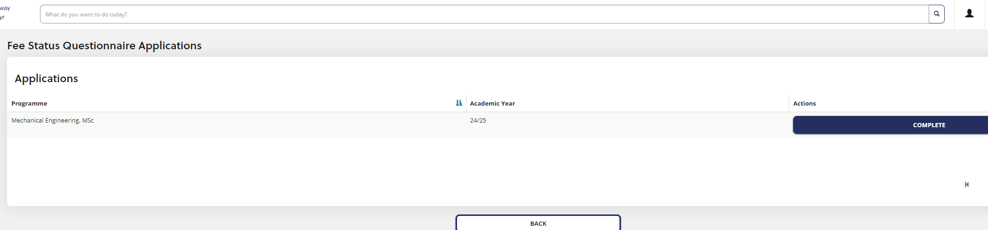

- You will then see the Fee Status Questionnaire screen where you will first need to complete address/residency details.

The residency details section is where you need to put all your residency information and the purpose of your residence. You can add multiple records if needed.

You should put up to at least 5 years’ worth of residency details in this section. For the address that’s your current residence, you need to put a tick in the box above Country
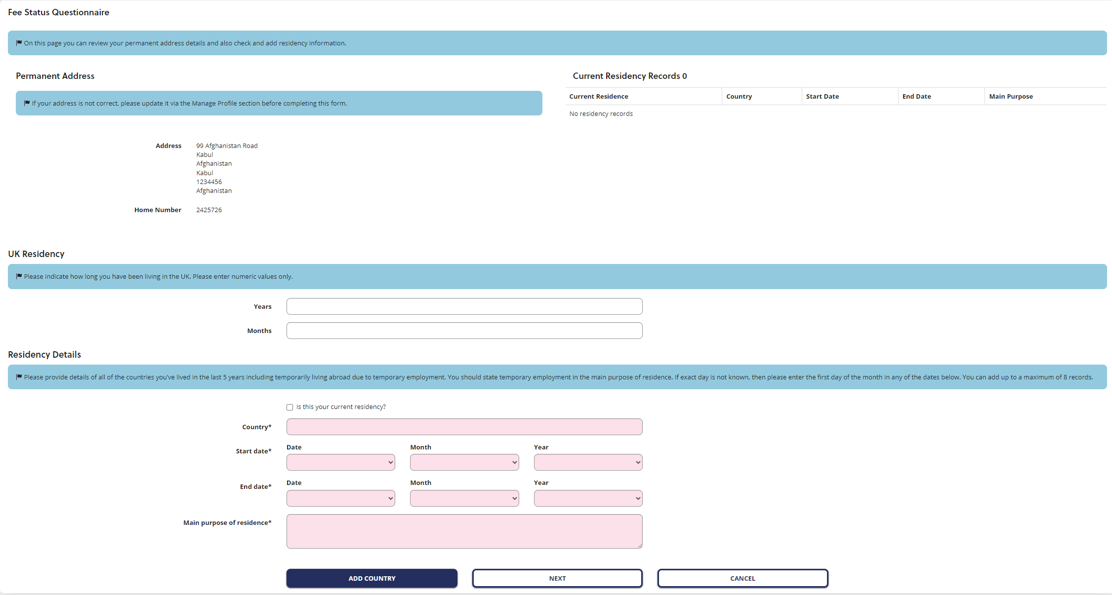

- Once you have put in your initial residency details, click “Add Country” and you will see this screen where you can create another record or move on to the next screen.

Reminder you should put at least 5 years’ worth of residency details.

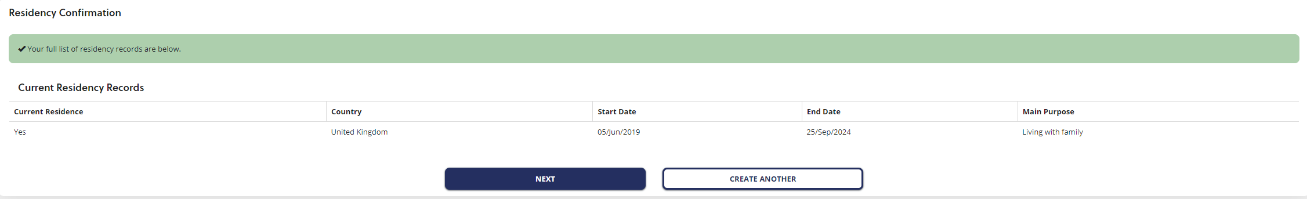

- Next, you will need to state your immigration status and upload copies of your immigration documents.

Here, the advice is to upload your passport (if you haven’t already done it at application stage), your share code and, if required, your Home Office letter. You can also upload proof of residency documents here.

You can upload evidence via the “Upload Evidence” button and you should be able to upload multiple documents. Then click “Save and Next”.

If you do not upload everything, don’t worry as we can request further information at a later stage.

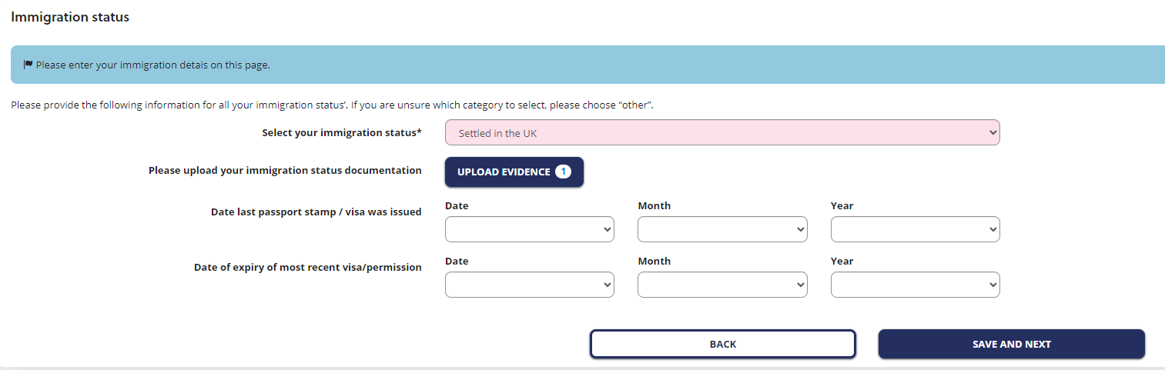

- The next step is to advise us where you are currently living.

You need to complete both questions as they are mandatory, even if you have never left the UK/EEA/Overseas Territories.

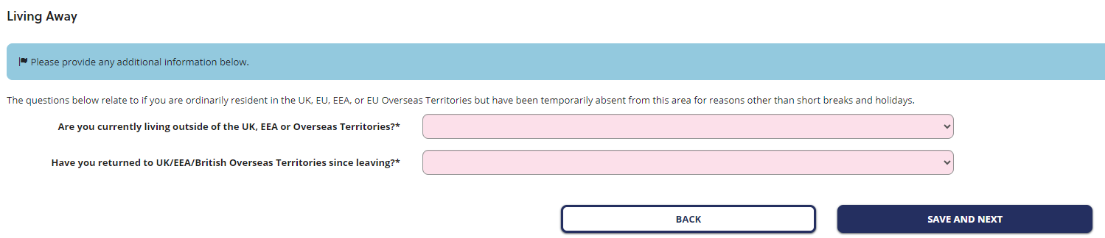

If you have never left the UK/EEA/Overseas Territories, answer “no” to the second question that asks if you have returned.

If you tick yes, you have returned, you will get the screen below appear that then asks for links to UK whilst you’ve been away and asks you to upload evidence (so if you’ve never left and don’t need to provide this information, you need to select no to the “have you returned” question).

This question would be specific to anyone who has temporarily left the EEA, e.g. British Citizens who have been living outside the EEA

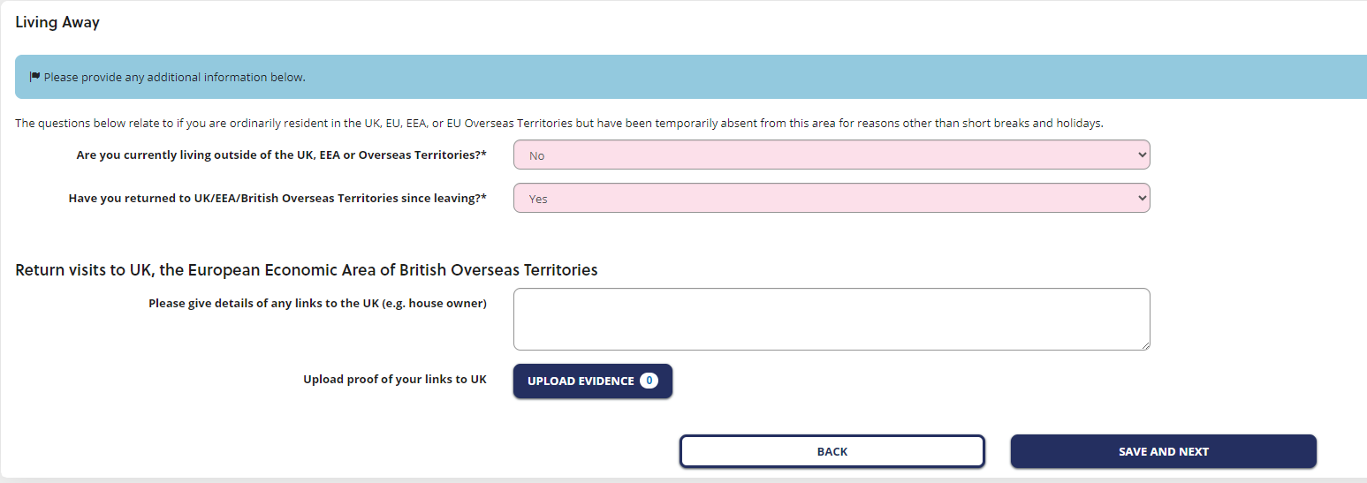

- The final section of the questionnaire is a free text box where you can put any further information that you feel is relevant to your fee query

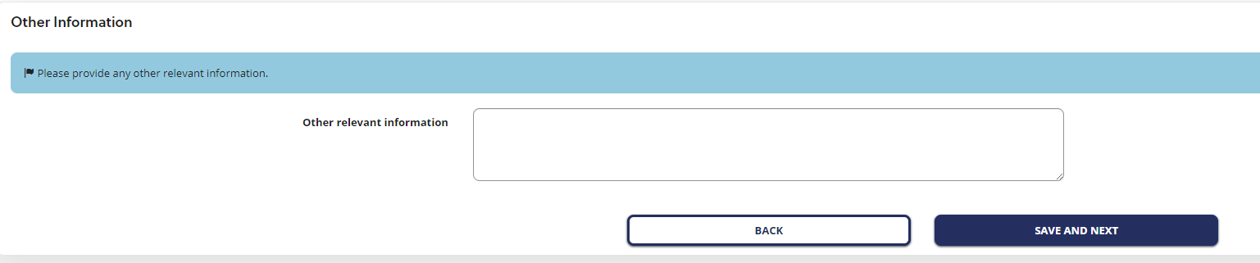

- You can then exit the form

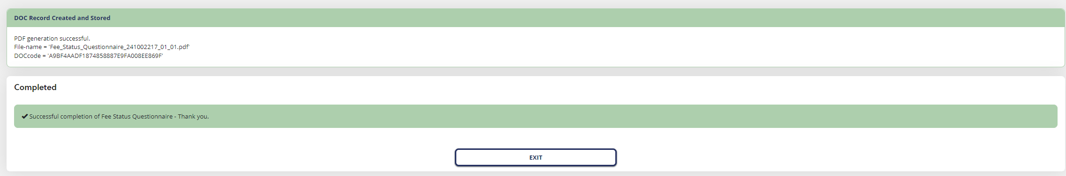

- Once you exit it will then go back to the main Application Dashboard. You can complete any further tasks there while you wait for your fee status questionnaire to be reviewed

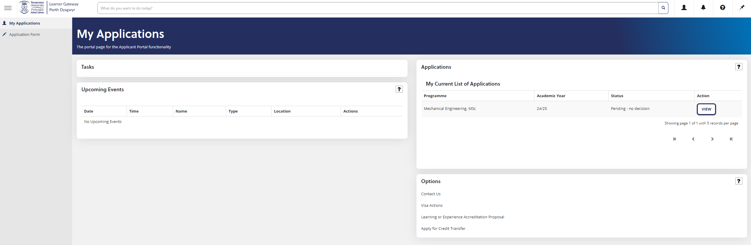

- If we request further information or documents from you in support of your fee assessment, you will receive a notification

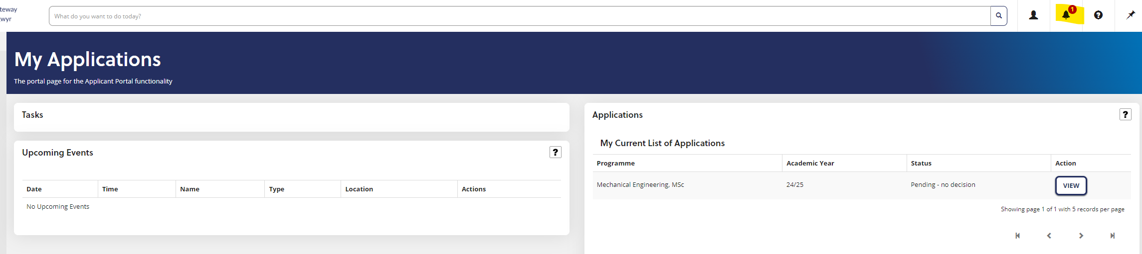

- Click on the notification and it will take you to your “Advanced Intray”

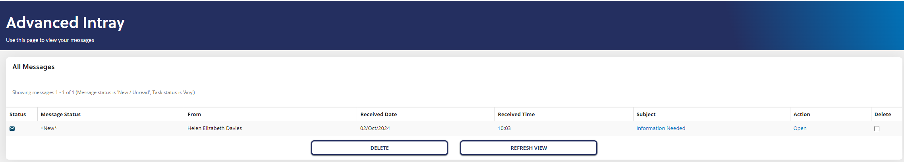

- You need to click on the blue link in the “Subject” column to go into the message.

- You will then see the message from us requesting further information and what it is that we require.

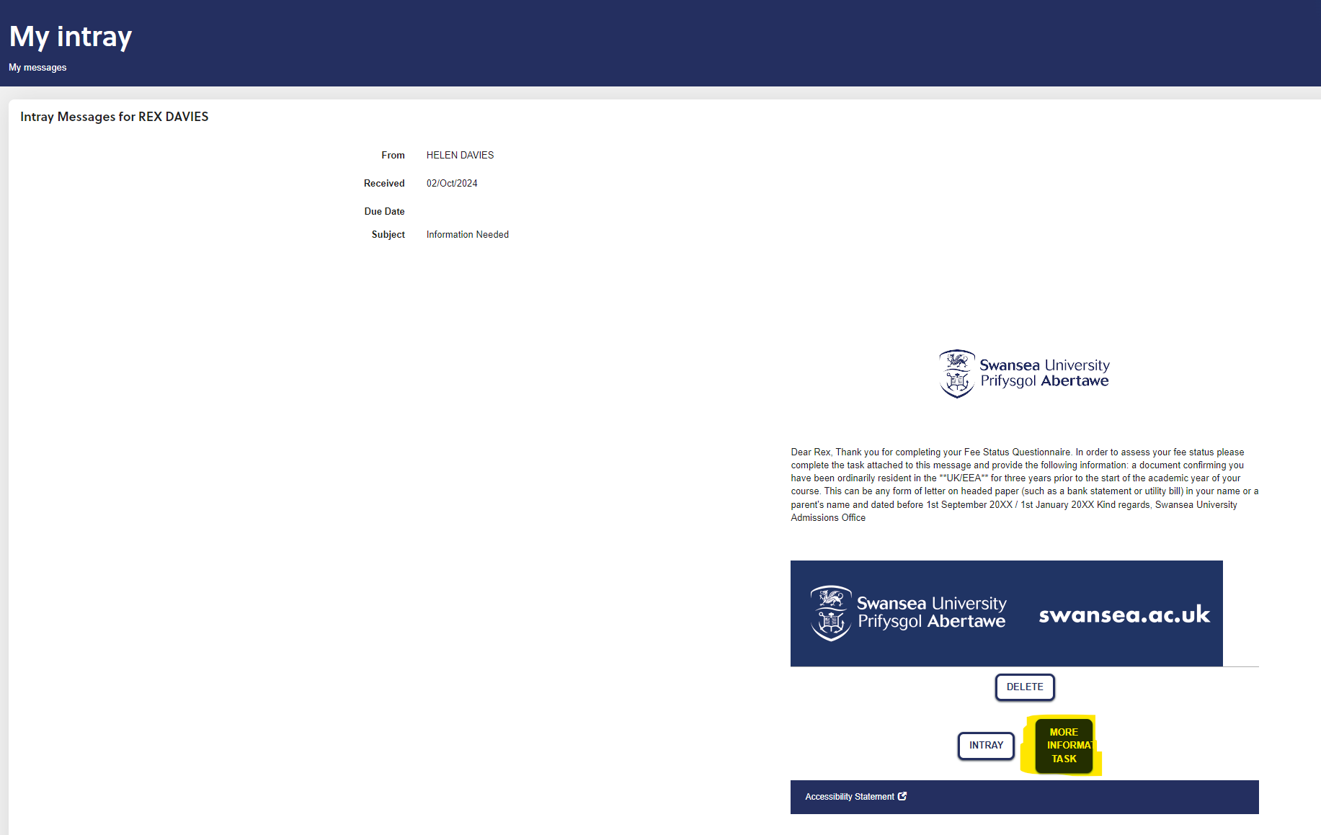

- Click on “More Information Task” and it will take you to the “More Information Requested” section where you can upload further evidence and write a response back to us, then click “Next”

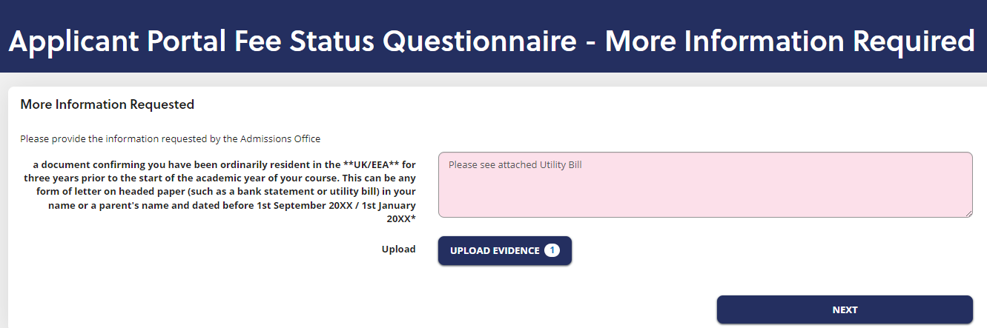

- You then click “Finish”

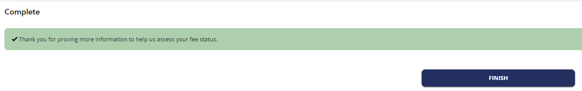

- If your Fee Status in your record shows “Query”, it means that it either is awaiting initial review, is on hold pending further information from you or is waiting for a second assessment because you have provided further documents or information.

You should be aware of the stage your fee assessment is at because all communication is completed via the Learner Gateway.

Your record will show Pending Final Assessment once the assessment has been reviewed by an Advisor and is awaiting final sign off by an Officer.

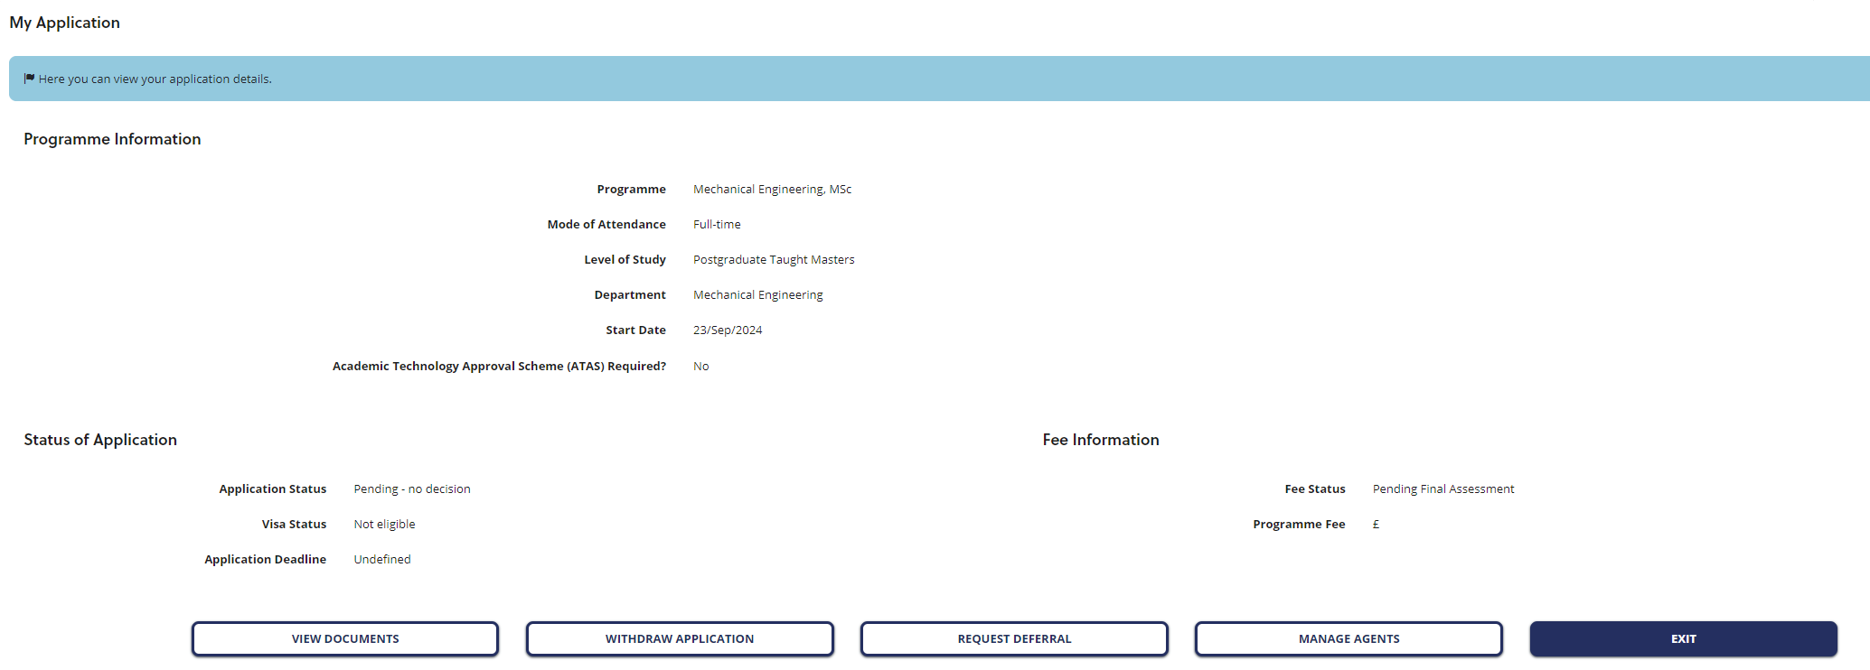

- Once your fee assessment has been completed, you will receive a notification to say a message has been received. If you click on the notification, it will take you to your Inbox where you will see a message titled “New Fee Status Assigned”

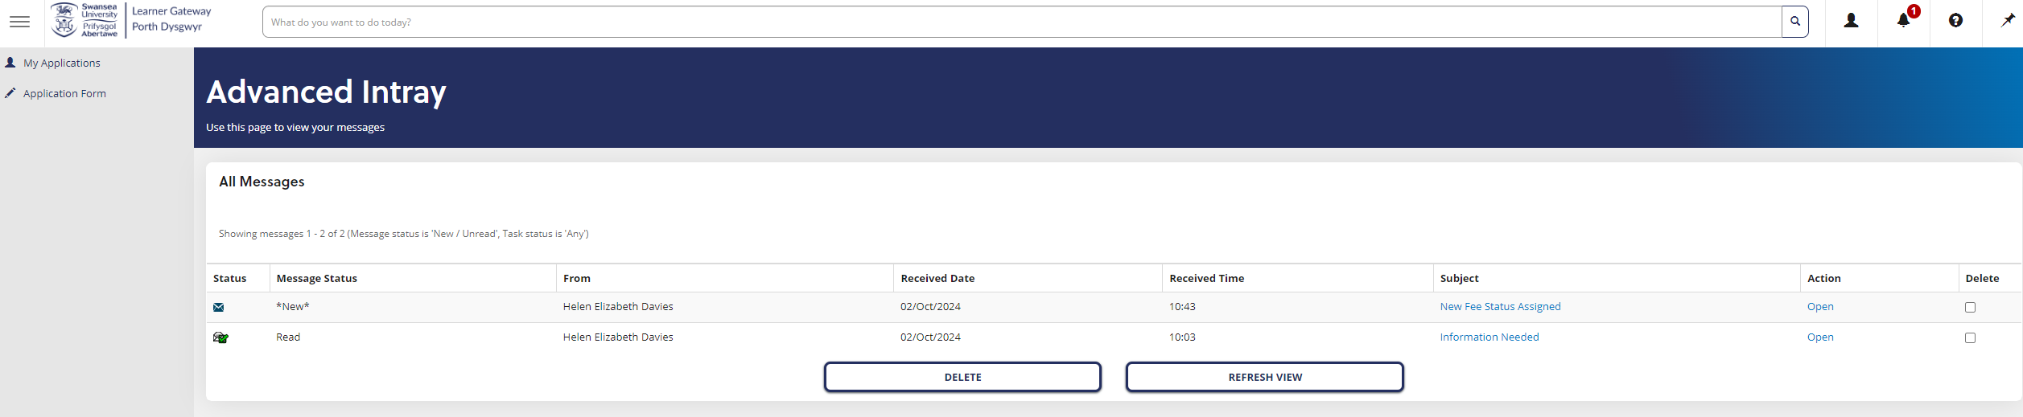

- Click on the link in the “Subject” column to open the message. You will see the outcome email for Home or Overseas (depending on outcome)

Your fee status on your record will change from Pending Final Assessment to Home or Overseas

