Parking
This event has free of charge reserved parking in the Bay Studios car park from 6pm, if you arrive before this time limited spaces are available and parking charges apply. For blue badge holders, please advise your registration details for parking on campus nearer the event venue.
Directions to Bay Studios Car Park
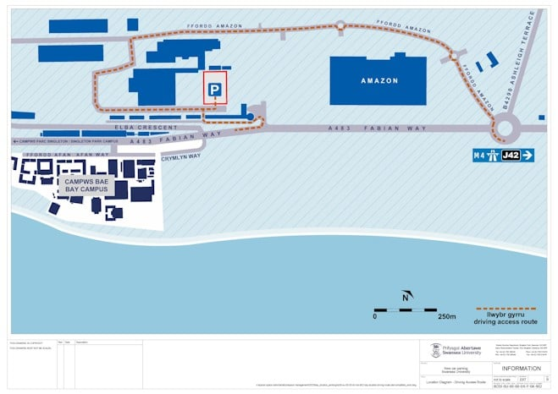
From M4 J32:

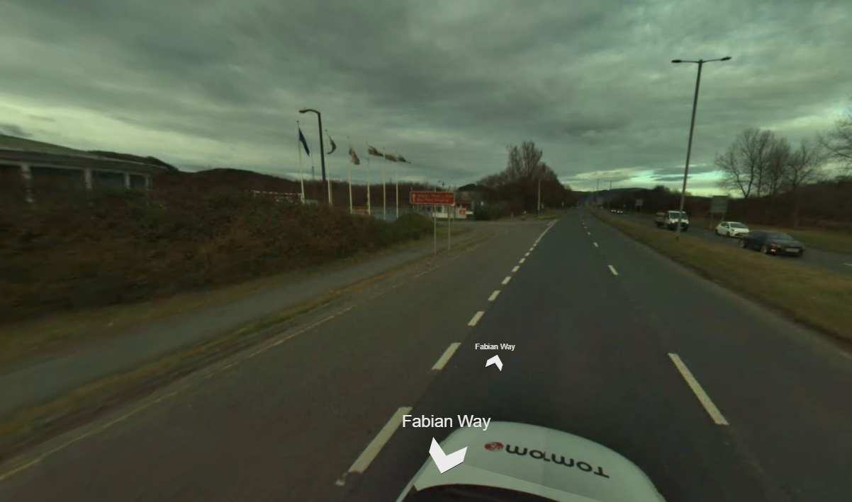
From Swansea City Centre, turn left at The Furniture Trader on Fabian Way.
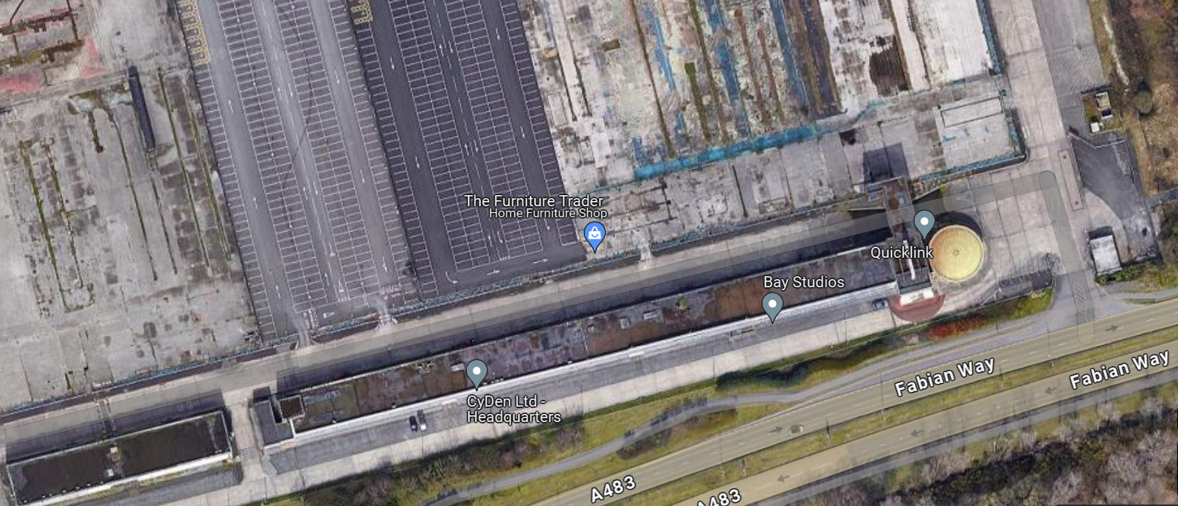

Directions from Bay Studios to Bay Campus
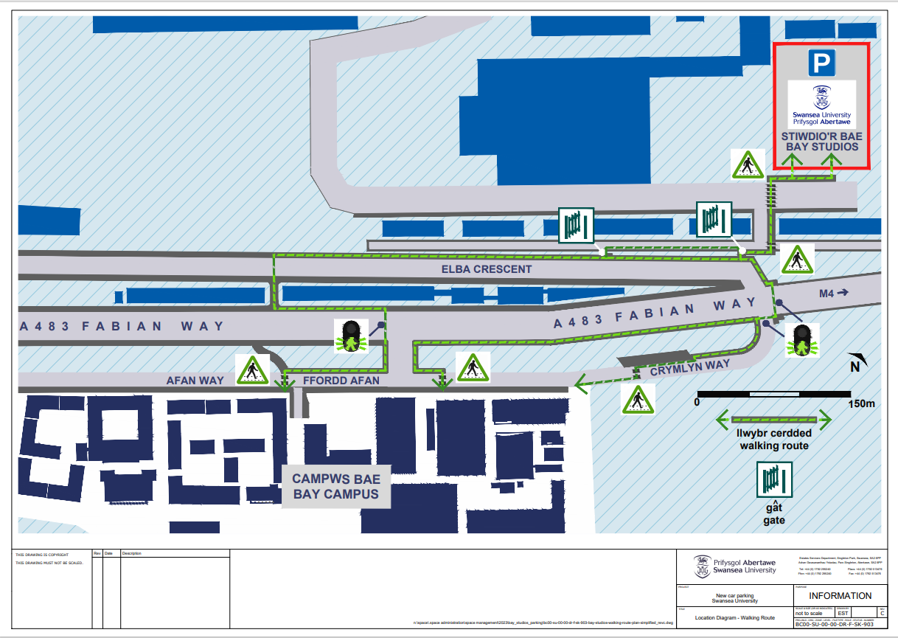
The talk will take place in Great Hall (number 6 on map).
