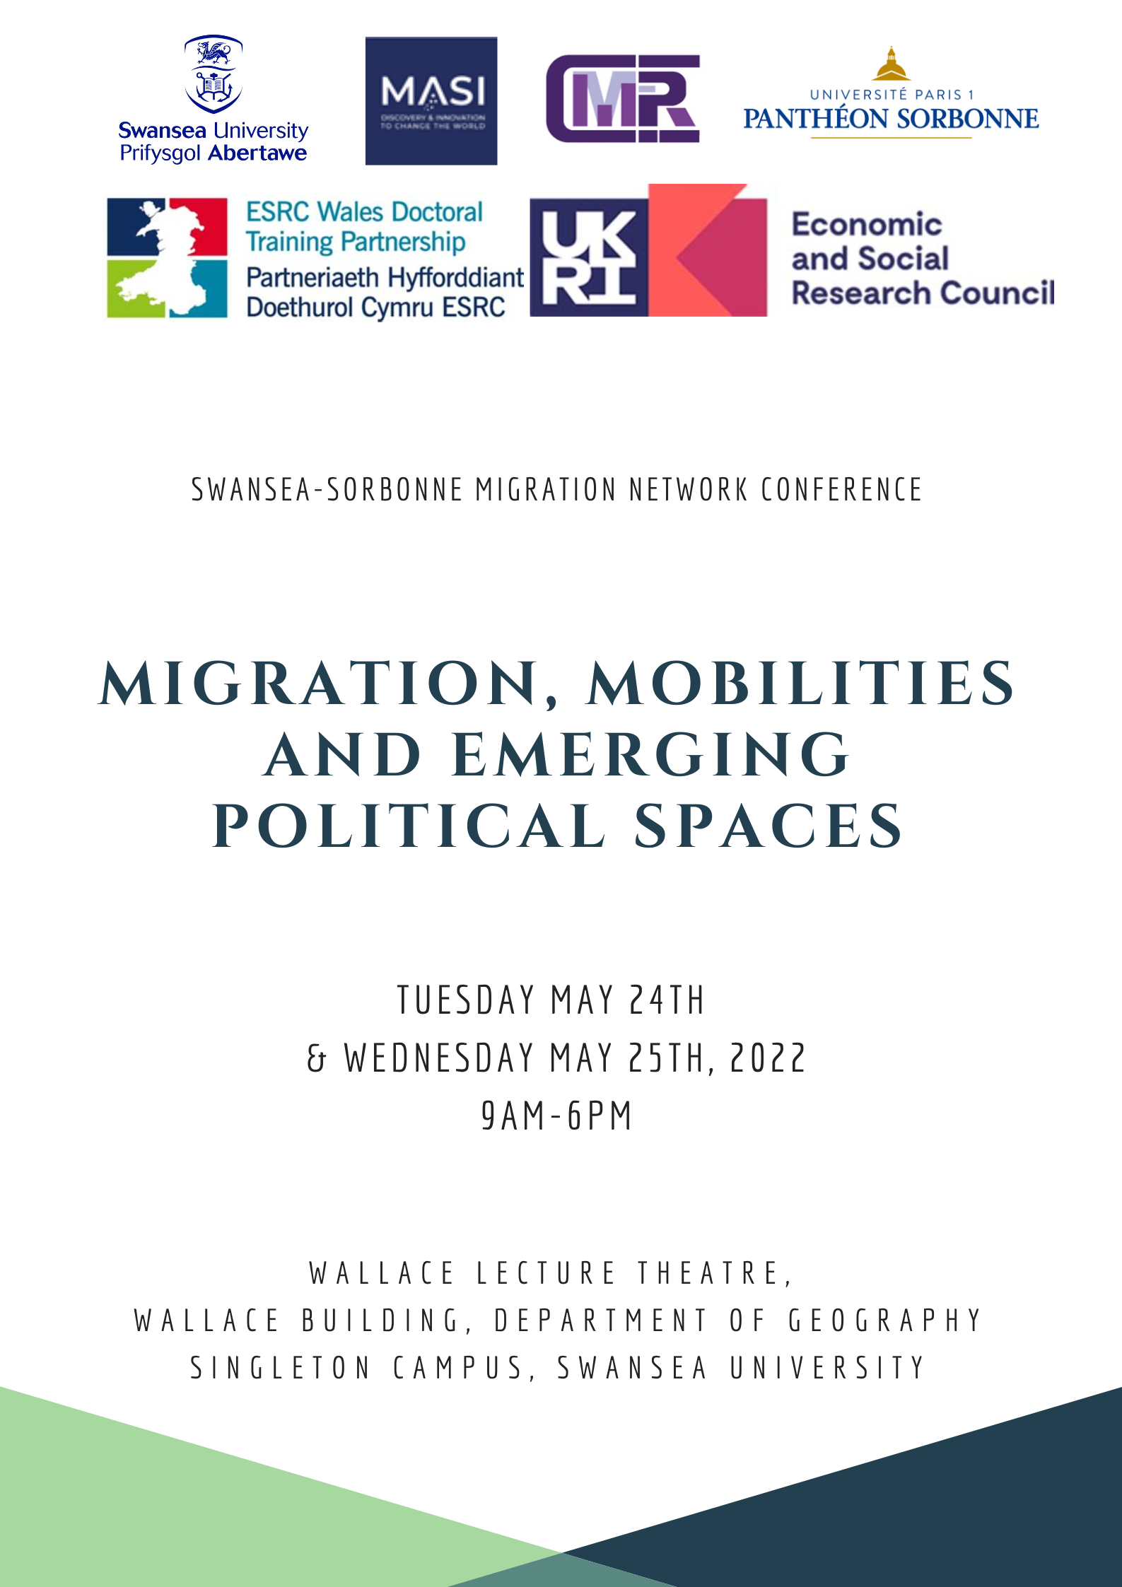

Monday 23 May 2022 – Arrival of the attendees
Pm: Process of arrival of attendees
6pm: Welcoming informal drink session at the Grape & Olive bar at the Meridian Tower

Tuesday 24 May 2022 (9am-6pm)

09.00-09.30: Registration and Welcome

09.30-09.45: Welcome introductions from Professor Sergei Shubin as head of the Migration Policy Research Centre at Swansea University and the organisers (Dr Franz Bernhardt and Mila Sanchez).
09.45- 10.15: Keynote Lecture by Professor Yann Richard, Sorbonne University
– The forgotten regionalization of international migrations?
10.15-10.45: Q&A for Keynote Lecture One

10.45-11.00: Coffee Break

11.00-13.00: Panel 1 + Q&A for Panel 1. Chaired by Dr Chris Muellerleile.
Regionalization, Migration, and the Nation-State
Presenters: Professor Oscar Garcia Agustin, Dr Franz Bernhardt, Dr Aled Singleton, Bethan Hier

13.00-14.00: Lunch Break

14.00-16.00: Panel 2 + Q&A for Panel 2. Chaired by Professor Sergei Shubin.
Emerging Spaces and Mobilities- Perspectives from South America, Africa and beyond
Presenters: Professor Clarisse Didelon-Loiseau, Kossigari Djolar, Felix Gueguen, Khadija Medani

16.00-16.20: Coffee Break

16.20-17.00: Swansea City of Sanctuary; Presentation “Wrecked Train”
Presenter: Carlos Ibarra Rivadeneira
17.00-18.00: Q&A for Swansea City of Sanctuary

7pm: Meeting for the Conference Dinner at Founders & Co

Wednesday 25 May 2022 (9am-6pm)

09.00-09.10: Dr Franz Bernhardt introduces the second keynote speaker.
09.10-10.00: Keynote Lecture by Professor Maja Zehfuss, University of Copenhagen
– Migration Politics: People in Time in a Spatialised World
10.00-10.45: Q&A for Keynote Lecture Two

10.45-11.00: Coffee Break

11.00-13.00: Panel 3 + Q&A for Panel 3. Chaired by Professor Marcus Doel.
Narratives, Migrant Identities, and the Politics of Affect
Presenters: Myrian Ouellet, Dr Angharad Closs Stephens, Professor Sergei Shubin

13.00-14.00: Lunch Break

14.00-15.00: Panel 4 + Q&A for Panel 4. Chaired by Dr Keith Halfacree.
Creative Methodologies and Activism in Migration Studies
Presenters: Sarah Foster, Professor Pierluigi Musaro, Dr Eleanor Cotterill

16.00-16.20: Coffee Break

16.20-16.30: Presentation of the Morgan Advanced Studies Institute (MASI).
16.30-17.00: EYST
17.00-17.30: Q&A for EYST

18.00: Closing words by the organizers.

8pm: Drinks at the No Sign Bar

About EYST Wales
Ethnic Minorities and Youth Support Team (EYST Wales www.eyst.org.uk) is an award-winning and beneficiary-led charity which was set up in 2005, initially to support Black, Asian, and Minority Ethnic young people, and then expanding its scope to supporting all ethnic minority people living in Wales. Over the last 17 years it has grown to become the leading ethnic minority organisation with a staff team of 70 staff based right across Wales including Swansea, Newport, Cardiff, Wrexham, and mid-Wales. Thanks to a range of funders, we are able to deliver a wide range of services and activities focused around our 5 key pillars of work, which are:
· Supporting ethnic minority children and young people
· Supporting ethnic minority families
· Supporting refugees, asylum-seekers, and migrants
· Supporting ethnic minority community groups
· Challenging Racism in Wider Society
As well as delivering services to over 5000 individuals per year, EYST also plays a key strategic role in Wales, being the Welsh Government-appointed Lead Body for Race, a role we have had since 2017, and through which we deliver the All Wales Black and Minority Ethnic Engagement Programme. We also play an active and strategic role in refugee and asylum issues, being integral members of the Welsh Refugee Coalition, the Wales Strategic Migration Partnership, and others.
Importantly, EYST is led by and for ethnic minority people, with around 85% of our current staff team being from a non-white, non-British background, including our Co-Director Helal Uddin; and around 65% of our current board members, including our Chairperson Dr Shehla Khan. This is based on our commitment to valuing the lived experience of people who have lived through the same issues we are seeking to address. Our core organisational values are commitment to equality and diversity, social justice, and human rights, and making a positive difference in other people’s lives. We have many achievements we are proud of, from buying our premises in Swansea in 2019, to our award for most Admired Organisation in 2014, and Best Third Sector Employer in 2016. But what we are most proud of is the difference we are making every day to people on the ground, helping them get a job, or helping them get through a difficult day - this is what matters most to us.

Information concerning Travel and Accommodation for attendees
The conference will be taking place at the Wallace Lecture Theatre, Wallace Building, Department of Geography, Swansea University, Singleton Campus, SA2 8PP Swansea on the 24 & 25 May 2022.

Hotel:
You will be staying at: Travelodge Swansea Central, 1 Princes Way, SA1 3LQ
23-26 May 2022
Your room and breakfast as well as WIFI have already been paid but you will need to pay yourself for any extras.

Event:
Registration for the event will be from 9am (Tea and Coffee available) on Tuesday 24th May 2022 with a 9.30am start.
If you wish to log on to the Visitors Wi-Fi, please use the following link - https://swanseauni-wifi.swan.ac.uk/visitors.php

Drinks and Dinner:
In order to greet the attendees arriving from abroad, we will have a voluntary welcoming drink from 18.00 to 20.00 at the 23 May 2022 at the Grape & Olive bar and restaurant at the top of the Meridian Tower (The Tower, Trawler Rd, Maritime Quarter, Swansea SA1 1JW), to which people are invited to arrive to at any time with regards to their own arrival in Swansea.
The official conference dinner will take place on the 24th of May 2022 at 7pm at Founders & Co (24 Wind St, Swansea SA1 1DY). For speakers and chairs, there will be a £20 voucher per person for your dinner.
After the last panel and presentation of the conference, we will have a leaving drink in the evening of the 25^{th of} May 2022 at 8pm at the No Sign Wine Bar (56 Wind St, Swansea SA1 1EG) – an old favourite bar of poet Dylan Thomas in the city centre of Swansea.

Expenses:
To claim your expenses for travel etc., please complete the claimant form that has been circulated via email and return to: 996082@swansea.ac.uk or franz.bernhardt@swansea.ac.uk
Receipts are to be attached as practical. Payments will be made into claimant's accounts directly. All expenses need to be returned by 31st May 2022.

Transport from Swansea train station to Travelodge Hotel
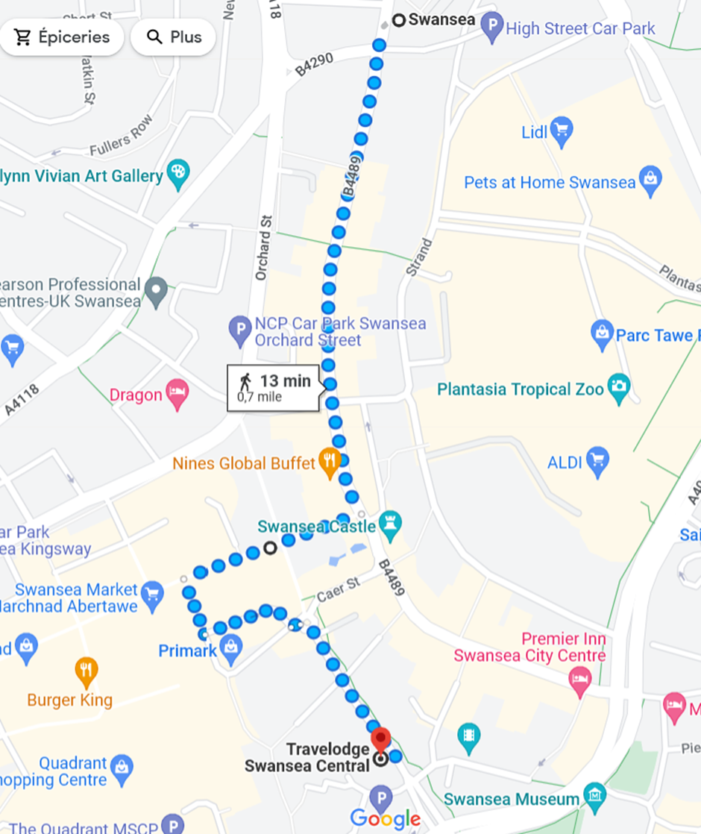
Map description for walking distance from Swansea Train Station to Travelodge Hotel

Transport to Swansea University:
By foot – 30 to 40 minutes by the seaside/coastal path.
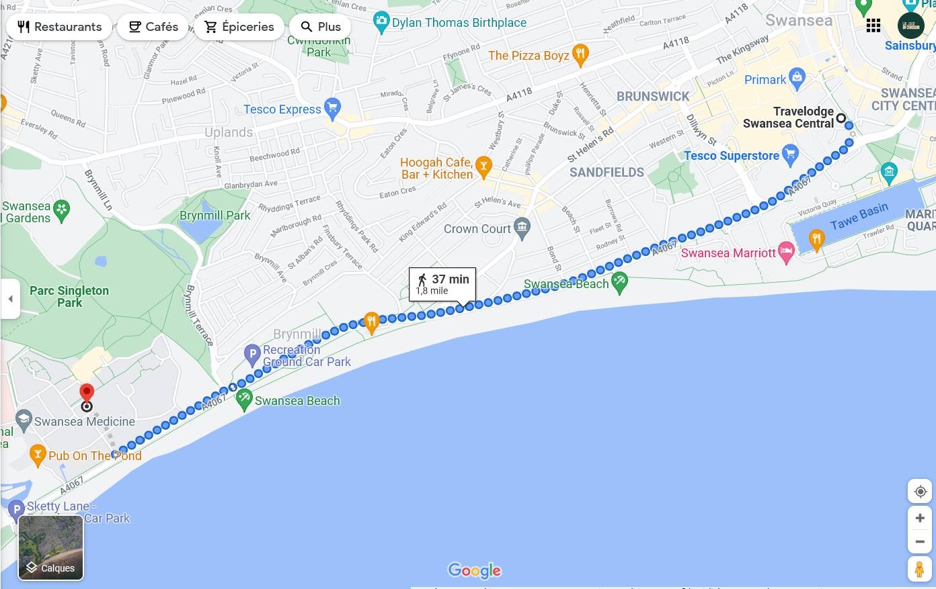
Map description for walking distance from Travelodge Hotel to Singleton Campus, Swansea University

By Bus – 20 to 30 minutes – From Sainsbury’s (n°9) or from the Swansea Bus Station (n° 4, 4A, 14, 2A, 3A) – Both stations are 5 minutes away (walking distance) from the Hotel.
N° 9 is running every 30 minutes Mondays to Saturdays. N°4, 4A every 15 minutes More information: https://www.firstbus.co.uk/south-west-wales/routes-and-maps/swansea-university
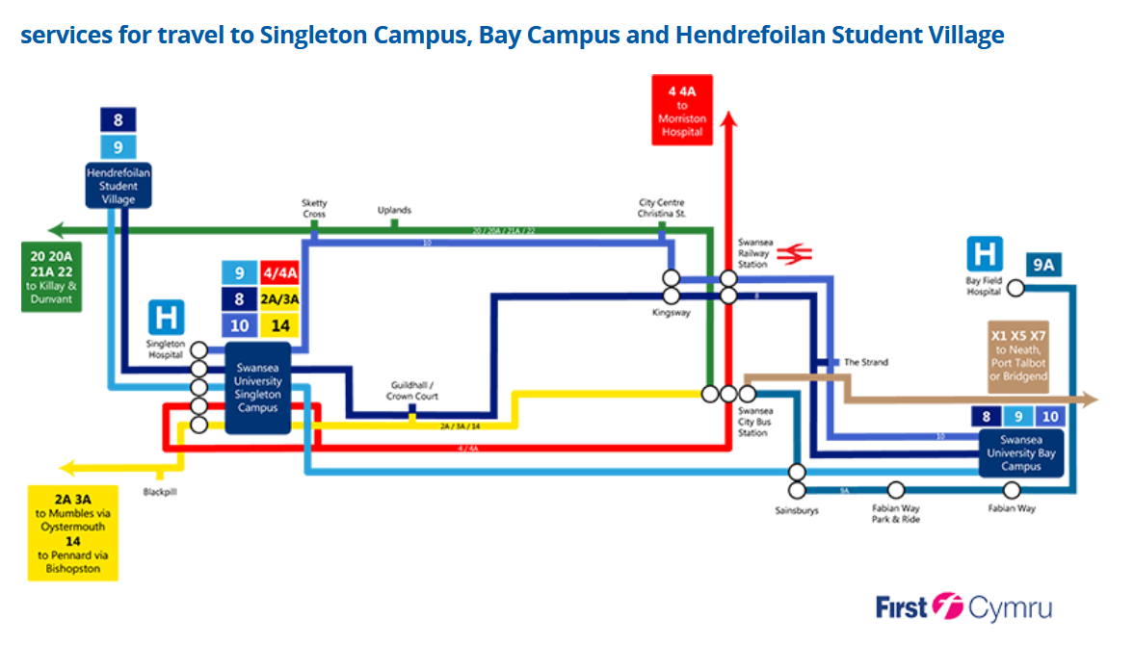
By Taxi
If you need to book a taxi, please find local taxi numbers below:
Yellow Cabs – (+44)01792 644446
ABBA Cabs – (+44)01792 475200
SA1 Cabs – (+44)01792 209925

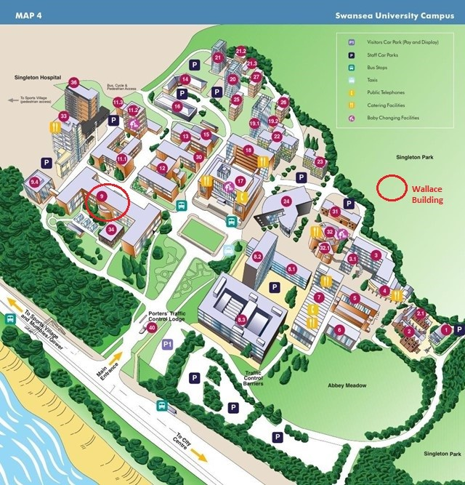
Map of the Singleton Campus, Swansea University
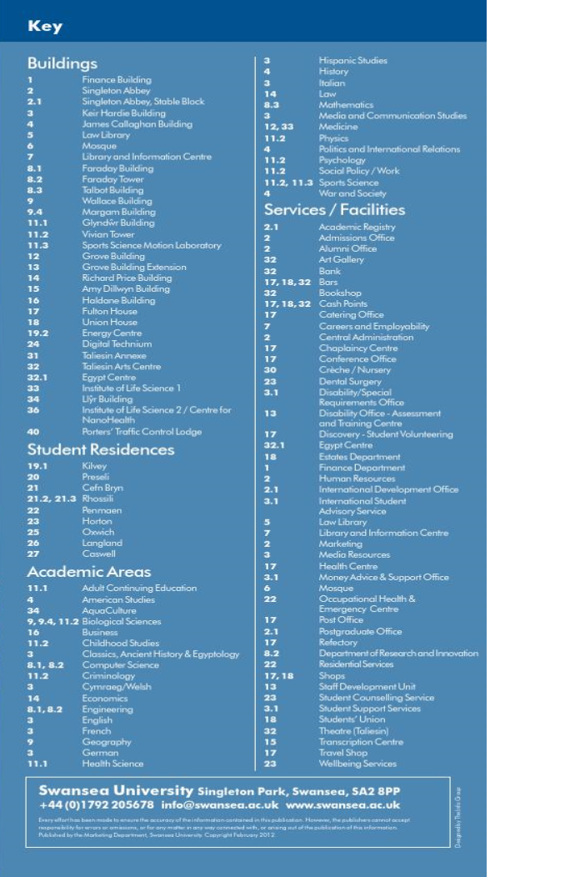
Key table for building descriptions at Singleton Campus Map

