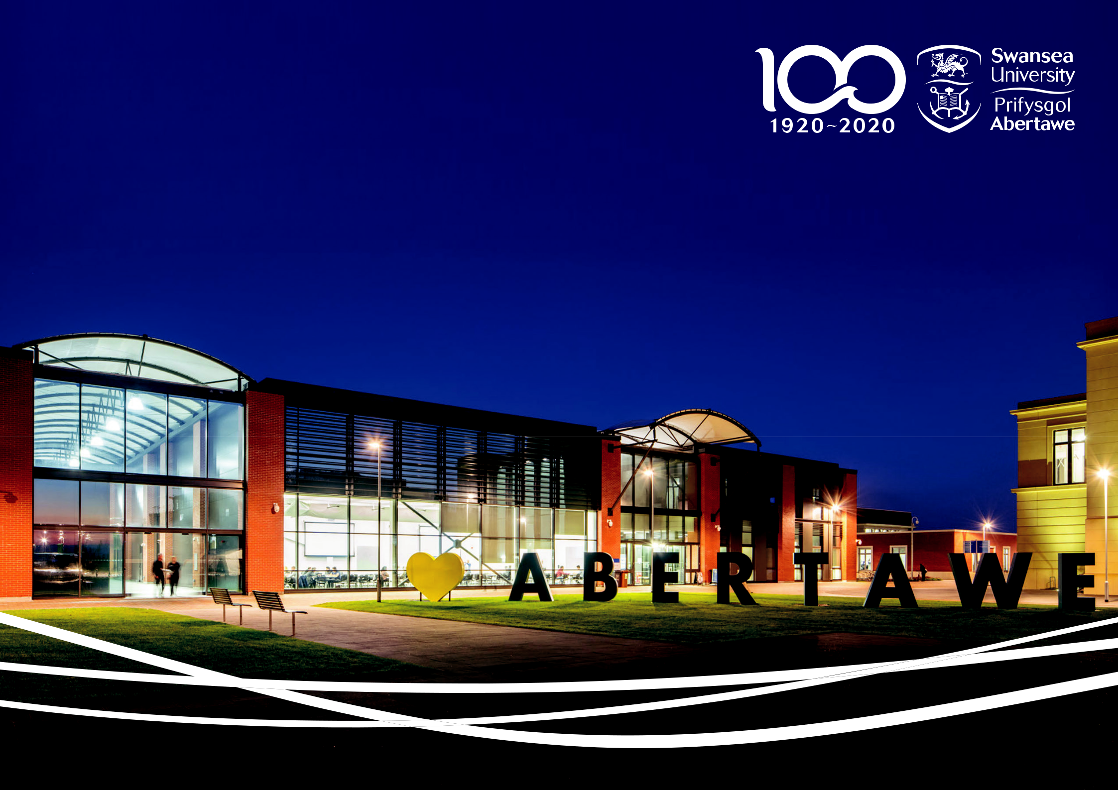

English Language Training Services, Swansea Academy of Academic Success

Make Waves at Swansea University. Join our team!

Swansea University
Making Waves Since 1920

As a research-led university, Swansea University has been making a difference since 1920.
The University community has a global presence and thrives on exploration and discovery,
offeringexcellent research and teaching, with an enviable quality of life for staff and students.

Swansea University has been awarded Welsh University of the Year 2019 after receiving the inaugural award in 2017 and is the runner up for UK University of the Year 2019. (Times and Sunday Times Good University Guide 2019). We have also been shortlisted for the UK University of the Year 2018 (Times Higher Education Awards).

Swansea University is a UK top 30 institution (30th) and top in Wales in the Times and Sunday Times Good University Guide 2019.

Swansea is in the Global Top 300 (251-300) best Universities in the THE World University Rankings 2017-18.

Now home to over 20,000 students, the University has enjoyed a period of tremendous growth and success, developing a new beachfront campus which is one of the largest knowledge economy projects in the UK and within the top five in Europe. We are also a UK top thirty research intensive University (2014 - 2021 Research Excellence Framework).

Over the last five years the University has also achieved a 70% increase in research funding and secured partnerships with global players such as Santander Universities, Fujitsu, Tata and Pfizer.

As our global impact increases more high calibre international students, leading academics and professionals are choosing to study and work with us. The vibrant mix of nationalities and cultures on campus greatly enriches our learning, teaching and working environment.

English Language Training Services

At ELTS we pride ourselves on our professional, high quality English language training, and offer a variety of EFL, EAP and ESP programmes, as well as CELTA teacher training courses. Whilst our primary concern is linguistic development, the pastoral care of our students is always at the centre of what we do, too. An ethos of strong, supportive personal contact runs through all ELTS activities, and we

ELTS Summer Academic Pre sessional Teams.

There are three pre-sessional programmes that run over the summer to cater for different student needs.

HEAD OF ELTS

JO PARFITT

j.f.parfitt@swansea.ac.uk

LEVEL 1 PRE SESSIONAL |  |  | LEVEL 2 PRE SESSIONAL |  |  | LEVEL 3 PRE SESSIONAL
12 WEEK COURSE |  |  | 10 WEEK COURSE |  |  | 8 WEEK COURSE
(10/6/24-30/8/24) |  |  | (24/6/24-30/8/24) |  |  | (8/7/24-30/8/24)
COORDINATOR – JOANNA CHAPMAN |  |  | COORDINATOR - ALISON DAVIES |  |  | COORDINATOR - ALISON DAVIES
Joanna.chapman@Swansea.ac.uk |  |  | Alison.J.Davies@Swansea.ac.uk |  |  | Alison.J.Davies@Swansea.ac.uk

BELFAST

DUBLIN

EDINBURGH

NEWCASTLE

LEEDS

LIVERPOOL

MANCHESTER

CAMBRIDGE

BIRMINGHAM

CARDIFF ^{LONDON}
BRISTOL

Benefits of working at Swansea University

Swansea University provides an enviable working environment, supported by a welcoming campus community. Our benefits are inclusive for staff of all backgrounds, including LGBT+ staff, disabled staff, pregnant staff, parents and carers, as well as staff of all genders, ages, ethnicities, nationalities, religion and beliefs, and marriage and civil partnership status.

The University was Awarded the Silver Athena SWAN Charter award for our commitment to promoting gender equality, one of just 16 in the UK, and are the 2nd highest scoring university in Stonewall’s list of inclusive places to work.

In addition to the pay and benefits listed in advertisements, the University also offers a range of benefits. Find out more on our website.

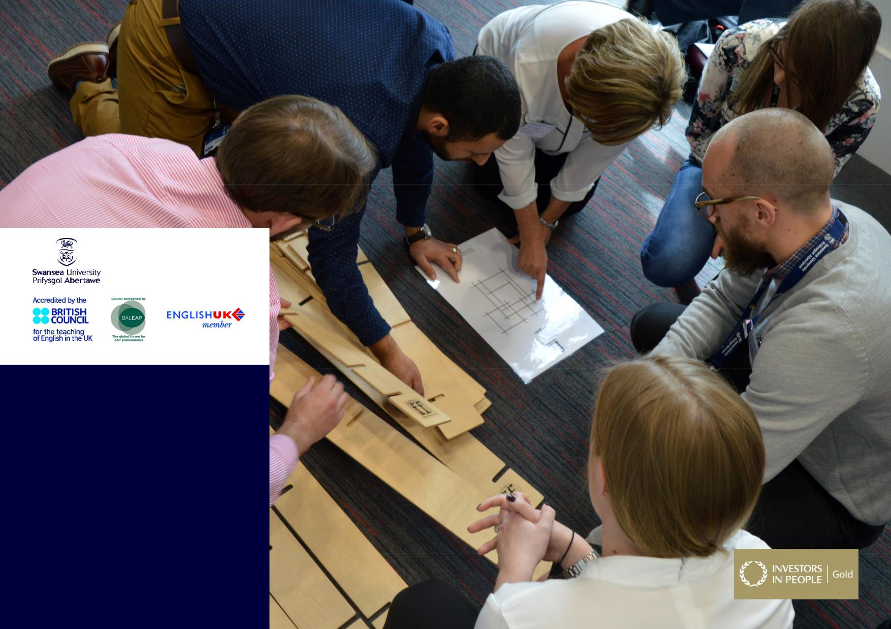

ELTS
English Language Training Services

ELTS commitment to

investing in people

There are paid induction days at the start of

your contract where you’ll meet the team and

have the chance to familiarise yourself with

the course expectations and your teaching

environment.

Benefits of working at ELTS include subsidised

staff accommodation on campus, a mentoring

scheme, regular CPD sessions and classroom

observations to encourage reflective practice.

Join Our Team!

Post Title:

Academic English tutor

Salary:

£32,982 per annum together with USS benefits Grade 7.

There will be a 2-day paid induction and annual leave entitlement.
Option to take up subsidised university accommodation.

Main Purpose of this post

Specific duties expected of English for Academic Purposes (EAP) Summer Tutors within the Department of English Language Training Services (ELTS);

- Tutors on full-time contracts are expected to teach up to 18 hours per week.

- ELTS teaching staff have a collective responsibility to cover teaching and marking loads for colleagues on sick leave.

- Assist with preparation of suitable material for all classes

- Assist with administrative duties as required in maintaining detailed records of attendance and work completed in each class.

- Liaise with other tutors over shared classes

- Conduct regular tutorials with students and report any problems to the Course Co-ordinator

- Keep to the marking schedules as required

- Attend team meetings as required

- Attend all student trips and excursions.

- Contribute to the overall development of the programme and department through feedback

General Duties

This appointment in the Department of English Language Training Services

(ELTS) has a number of generic objectives common to Tutor appointments within Swansea University. These relate to;

- Teach as a member of a teaching team in a developing capacity within an established programme of study in a variety of settings from small group tutorials to large lectures. Transfer knowledge in the form of practical skills, methods and techniques with the assistance of a mentor if required, challenge thinking, foster debate and develop the ability of students to engage in critical discourse and rational thinking.

- With support, develop own teaching materials, methods and approaches. Seek ways of improving performance by reflecting on teaching design and delivery and obtaining and analysing feedback. Reflect on practice and the development of own teaching and learning skills.

- Identify the learning needs of students and define appropriate learning objectives and give constructive feedback to students as required, provide advice on study skills and assist with learning problems.

- Interact positively and professionally with other collaborators and partners within the school, and elsewhere in the University.

- Contribute to School organisational matters in order to help it run smoothly.

- To promote equality and diversity in working practices and maintain positive working relationships

- To fully engage with the University’s Performance Enabling and Welsh Language policies.

- To conduct the job role and all activities in accordance with safety, health and sustainability policies and management systems, in order to reduce risks and impacts arising from the work activity.

Person Specification Criteria:

- A degree or equivalent in a related subject

- CELTA (Certificate in English Language Teaching to Adults) or CERT TESOL qualification

- Possess sufficient breadth or depth of specialist knowledge in the discipline and be developing further skills in, and knowledge of teaching methods and techniques

- Possess excellent organisational skills

- Possess excellent oral and written communication skills

- Demonstrate the ability to successfully teach students in an EAP setting

- Demonstrate excellent interpersonal skills and the ability to engage and enthuse students

- Demonstrate the ability to work as an effective member of the staff team responsible for educational provision in an EAP setting

- Demonstrate the ability to work within the framework of an agreed educational programme

Desirable Criteria:
- MA TEFL/TESOL or TEFL Diploma

- Evidence of commitment to Continuing Professional Development

- Experience of working on pre-sessional programmes

- Willingness to work outside contracted hours if a trip or social event requires you to do so

- The ability to communicate through the medium of Welsh

University Values:

All Professional Services areas at Swansea University operate to a defined set of Core Values (http://www.swansea.ac.uk/the-university/world-class/ values/professional-services-values/) and it is an expectation that everyone is able to demonstrate a commitment to these values from the point of application through to the day to day delivery of their roles. Commitment to our values at Swansea University supports us in promoting equality and valuing diversity to utilise all the talent that we have.

Essential Criteria:

Values

- We are professional

Demonstrable evidence of creating a culture that delivers successful outcomes through people, developing and challenging teams to succeed and take pride in delivering professional services and solutions.

- We work together

Ability to enable teams to work together and across functions to deliver successful outcomes that exceed the needs and expectations of customers, and in creating environments that demonstrate equality, foster trust, respect and challenge.

- We care

Demonstrable experience of creating environments that identify, understand and give priority to delivering the needs of the customer, and in motivating and inspiring teams to provide the highest standards of personalised care

Join our dynamic team

We look forward to meeting you.

To apply for the post please click on the link:

www.swansea.ac.uk/jobs

All interviews will be conducted via Zoom.

Find out more about ELTS at

www.swansea.ac.uk/english-language-training-services

For informal enquiries please contact

Alison Davies Alison.j.Davies@swansea.ac.uk
Joanna Chapman Joanna.chapman@swansea.ac.uk

